27U ENCLOSURE 19" CABINET 800X800 FLOOR STANDING DATA RACK - VALUCAB (BACKORDER)
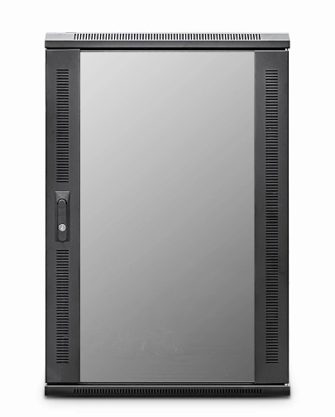

DESCRIPTION
Enterprise Level Quality With A Competitive Edge
Looking for a high-quality, UK assembled, floor standing data cabinet for your enterprise level applications but don’t want to pay the earth? The new LMS Data ValuCab Enterprise edition cabinets come in a variety of heights, widths and depths so will be ideal for almost all professional applications including that if data centres, IT departments, PBX exchanges in both enterprise, SME and public sector installations.
UK assembled means quality assurance is built in. Together with a superior manufacturing process, fully adjustable front and rear 19-inch uprights, choice of cable entry points, left-right hinged safety glass door and ease of post installation is assured thanks to removable side panels and rear door.
Bundled with castors, jacking feet and M6 captive screw assembly kit, the ValuCab also enjoys the vast amount of LMS Data accessories for the Enterprise edition series.

SPECIFICATIONS
27U high 800W 800D
ETSI 19” front/rear profiles, adjustable
Lockable vented glass door, reversible
Removable side panels, rear lockable door
Integral Front Cable Management fitted
Ideal for SME, IT Rooms, PBX & Broadcast
Fitted castors and jacking feet (4))
UK Assembled and quality assured

TECHNICAL INFO
SKU/MPN: CAB-FE-27U-88NA
EAN: 8400800034953
Dimensions: 800(width) x800(depth) x1370mm(height

FILES
Datasheet - CAB-FE-27U-88NA

